DevOps Assignment 3
Hamza Faheem

I) Login to Azure and run the following script in power shell:
$resourceGroup = "1-34ad3840-playground-sandbox"
$location = "West US"
$storageAccountName = "terraformactions"
$containerName = "terraform-state"

# Create an Azure Storage Account
New-AzStorageAccount -ResourceGroupName $resourceGroup -Name $storageAccountName -Location $location -SkuName Standard_LRS -Kind StorageV2 -AllowBlobPublicAccess $false

# Gather information about the storage account
$storageAccountKey = (Get-AzStorageAccountKey -ResourceGroupName $resourceGroup -AccountName $storageAccountName).Value[0]

$ctx = New-AzureStorageContext -StorageAccountName $storageAccountName -StorageAccountKey $storageAccountKey

# Create an Azure storage container inside the storage account
New-AzureStorageContainer -Name $containerName -Context $ctx

$OutputObject = [PSCustomObject]@{
resourceGroup = $resourceGroup
storageaccountname = $storageAccountName
containername = $containerName
}

$OutputObject | ConvertTo-Json

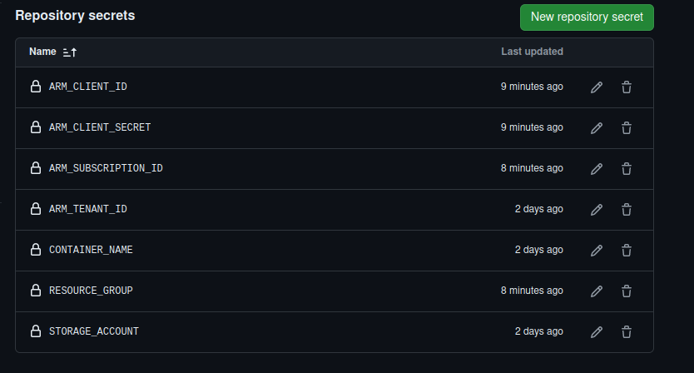
II) Add following secrets to github actions:
III) Add terraform and pipeline scripts
IV) Run the Github Actions Pipeline

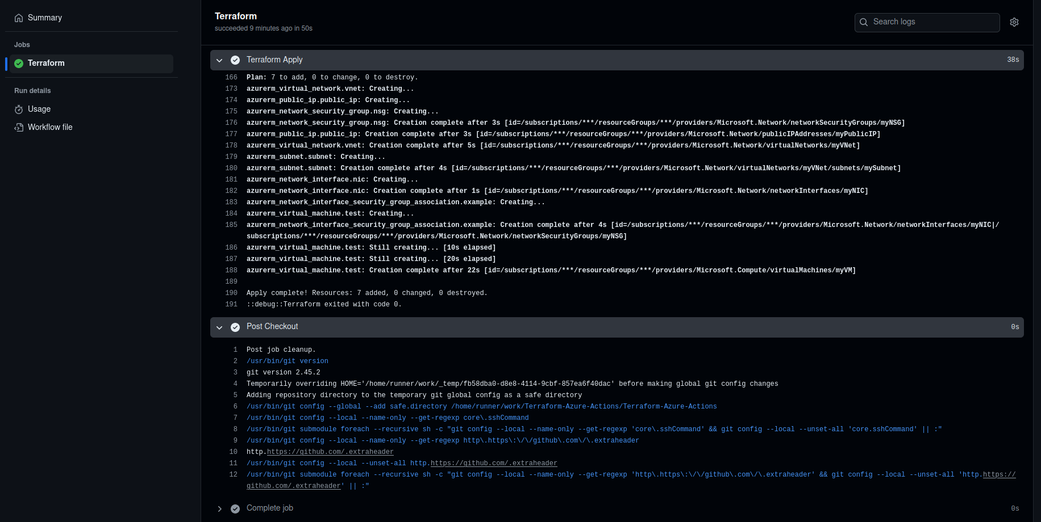
V) Run ansible
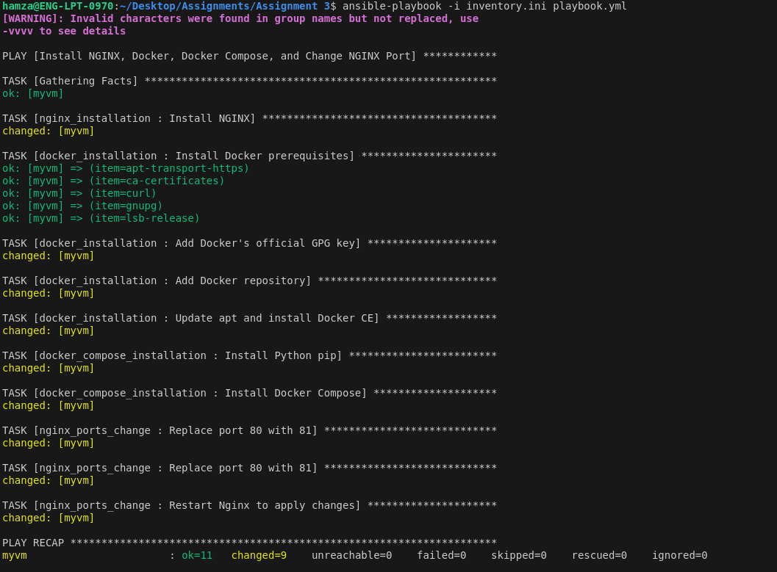

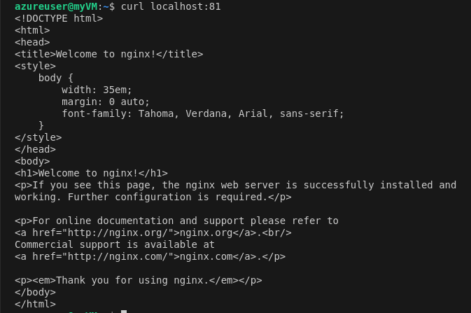
VI) Destroy!
